Name:
Dawood Sarfraz
Roll no:
20p-0153
Section:
BSCS-9A
Assignment no 4:
Build Automation (Pre-Processors)
Submitted to:
Dr. Omar Usman Khan

Task 3: Converting to Library
Static Library:

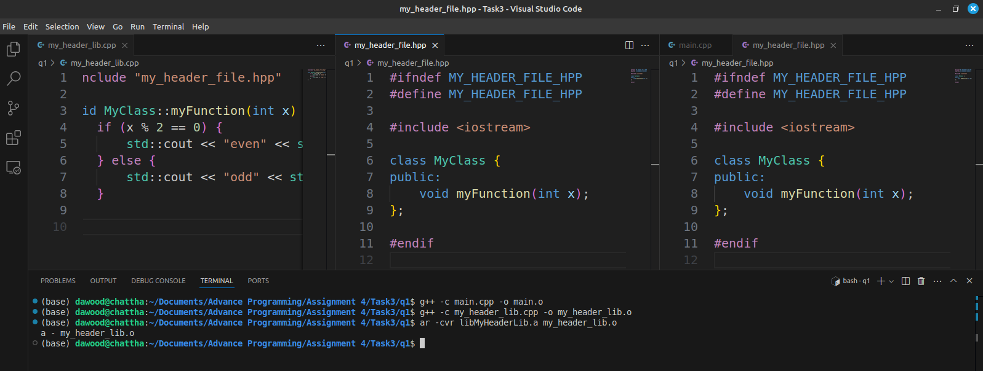

Dynamic Library:

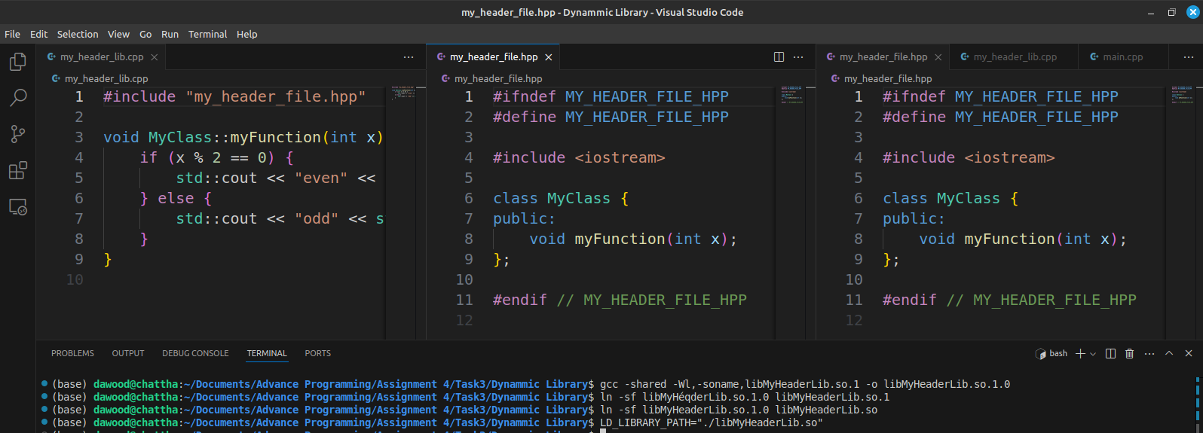

1. What is the directory structure of your code before and after the
library creation.

Before library creation:
├── main.cpp
├── my_header_file.hpp
└── my_header_lib.cpp

After library creation:
├── libMyHeaderLib.a
├── main.cpp
├── my_header_file.hpp
├── my_header_lib.cpp
└── my_header_lib.o

After dynamic library creation:
├── libMyHeaderLib.a
├── libMyHeaderLib.so
├── libMyHeaderLib.so.1
├── libMyHeaderLib.so.1.0
├── main.cpp
├── my_header_file.hpp
├── my_header_lib.cpp
└── my_header_lib.o

2. What are the CVR arguments?
CVR Arguments:

● C: Create a new archive.
● V: Verbosely list files processed.
● R: Replace or insert files into the archive.

3. Run the commands below and report their output:

1. readelf -S my_header_lib.o
Lists the section headers of the object file.

2. readelf -S your_final_file
Lists the section headers of the final executable.

